Week-3: Spring Core_Maven

**Exercise 1: Configuring a Basic Spring Application**

**Scenario:**

Your company is developing a web application for managing a library. You need to use the Spring Framework to handle the backend operations.

**Steps:**

**1.Set Up a Spring Project:**

* 1. Create a Maven Project

Open Eclipse IDE.

Go to File > New > Project…

Select Maven > Maven Project, click Next.

* **Group Id**: com.library
* **Artifact Id**: LibraryManagement

Click **Finish**.

* 1. Add Spring Core Dependency

Open the generated pom.xml and add the Spring Core dependencies:

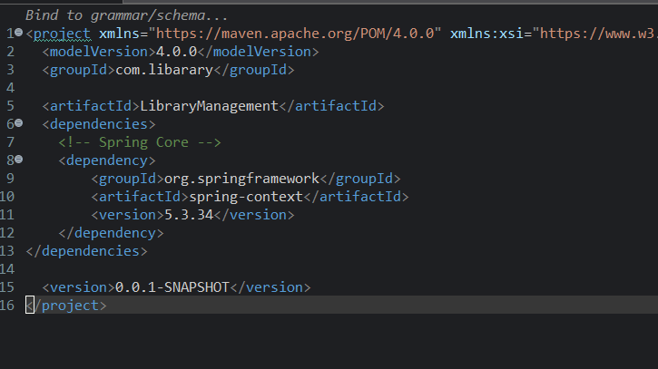

* **Step 2: Configure the Application Context**
* **2.1 Create applicationContext.xml**
* In your project, navigate to src/main/resources.
* Right-click > New > File > Name it applicationContext.xml.
* **2.2 Add Bean Configuration**

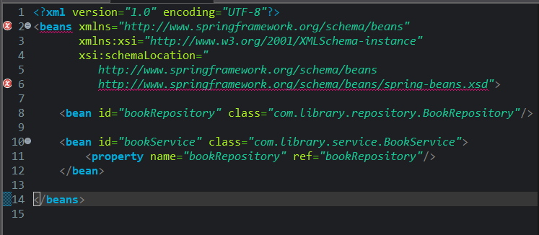

**Step 3: Create Service and Repository Classes**

**3.1 Create BookRepository**

* Create a package: com.library.repository.
* Add class BookRepository.java

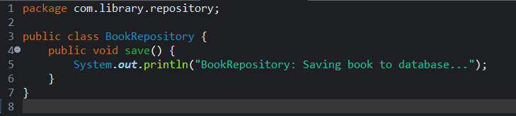

**3.2 Create BookService**

* Create a package: com.library.service.
* Add class BookService.java:

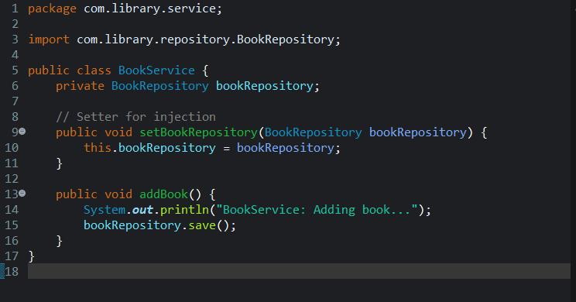

* **Step 4: Run the Application**
* 4.1 Create a Main Class

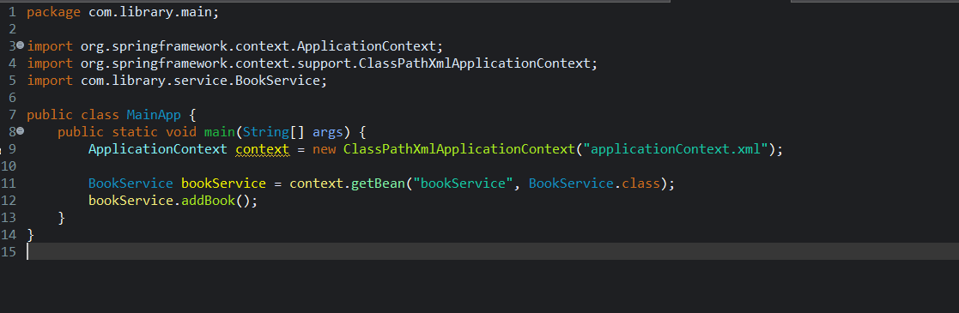

**Output**

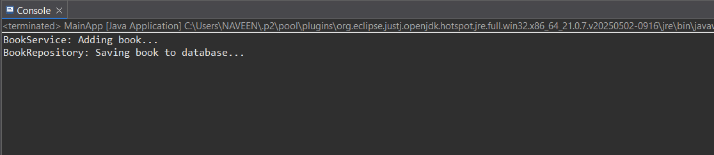

**Exercise 2: Implementing Dependency Injection**

**Scenario:**

**In the library management application, you need to manage the dependencies between the BookService and BookRepository classes using Spring's IoC and DI.**

**Step: 1.Modify the XML Configuration:**

* Update applicationContext.xml to wire BookRepository into BookService.

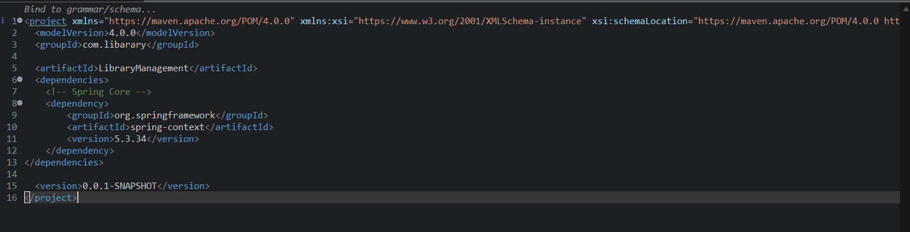

**Step:2. Update the BookService Class:**

* Ensure that BookService class has a setter method for BookRepository.

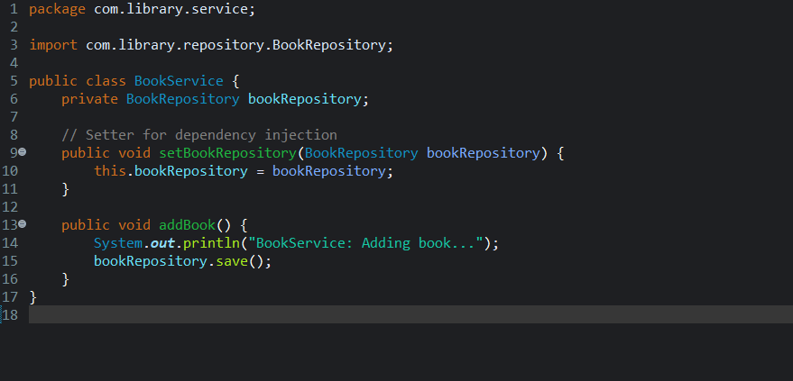

**Step 3:Test the Configuration:**

* Run the LibraryManagementApplication main class to verify the dependency injection.

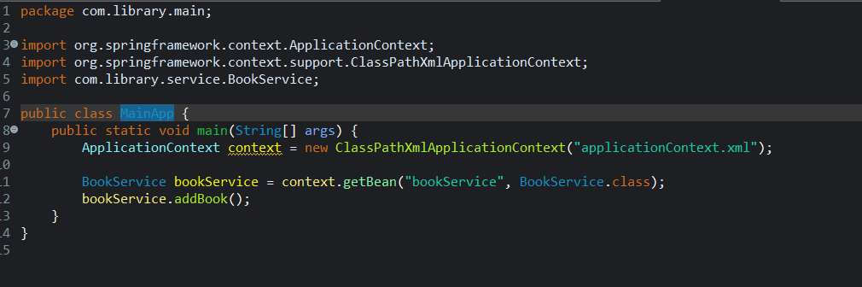

**Output:**

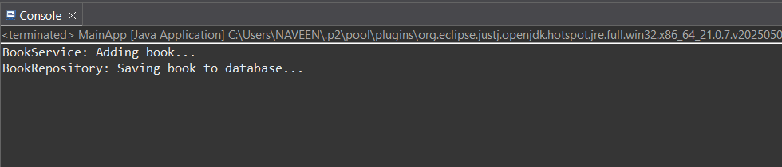

**Exercise 4: Creating and Configuring a Maven Project**

**Scenario:**

**You need to set up a new Maven project for the library management application and add Spring dependencies.**

Steps 1:Create a New Maven Project:

* + Create a new Maven project named LibraryManagement.

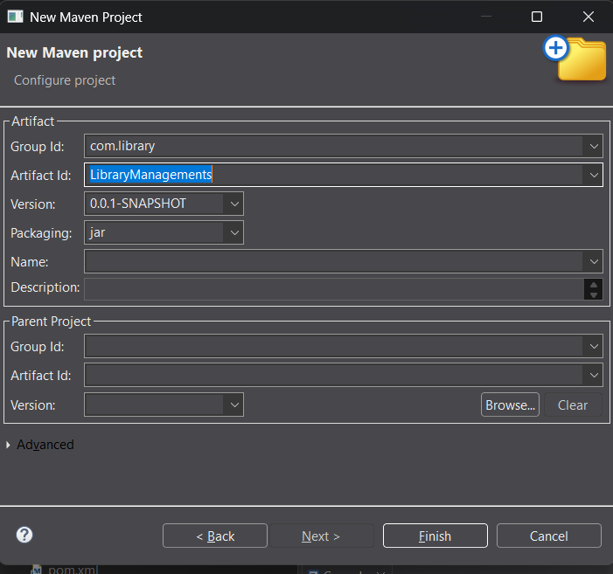

1. **Add Spring Dependencies in pom.xml:**
   * Include dependencies for Spring Context, Spring AOP, and Spring WebMVC.

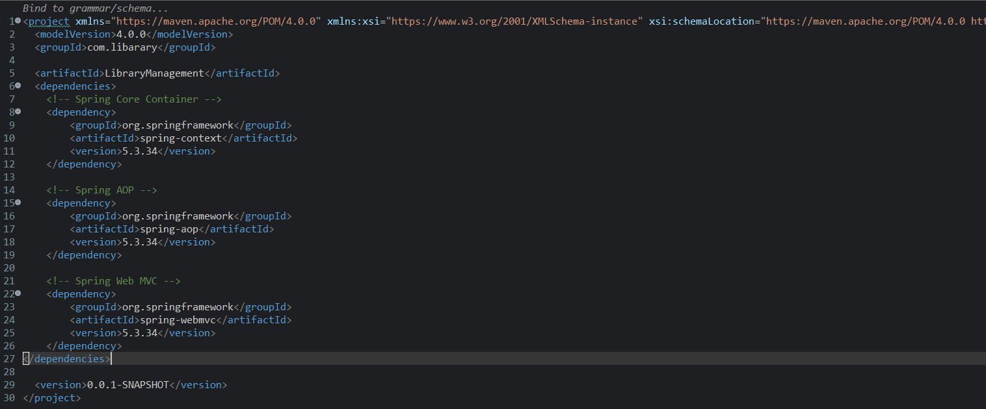

1. **Configure Maven Plugins:**
   * Configure the Maven Compiler Plugin for Java version 1.8 in the pom.xml file.

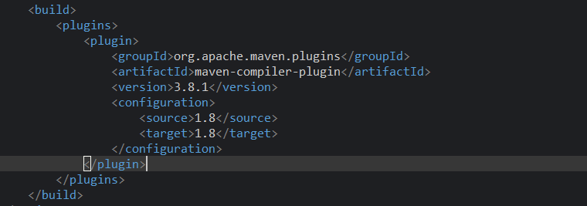

**Dependency hierarchy:**

